

**Model Driven Software Engineering**

**COEN-6312**

Instructor: Dr. Wahab Hamou-Lhadj

**Deliverable 2**

**Domain Analysis and Requirements**

**Team: Hungry for Troubles**

|  |  |
| --- | --- |
| Hem Raj Regmi | 40015416 |
| Bitta Rani Rana | 40031066 |
| Aeisha Vyas | 40043598 |
| Manjot Kaur Grewal | 40014336 |
| Harmanpreet Kaur Rajput | 40014345 |

**Table of Content**

Table of Contents

1. Textual Description of the Domain 3
2. Use Case 4

2.1 Use Case Diagram 4

2.2 Use Case Description 5

1. Functional Requirement 11
2. Contribution Table 12

**1. Textual Description of the Domain**

The aim of the University Management System is to handle all the activities and functionalities of a University, transforming the tiresome manual paperwork to a more efficient and faster automatic system. This will enable the management to focus on the more important tasks and let the system handle the other tasks which might not need the supervision of a personnel. This system will be able to efficiently handle most of the work done by the University management such as admission, fee and fine payments, course allotment, registration, class schedule, result declaration and much more. The student and faculty will also be able to enter their personal information like address, phone number, etc. and may also change these details if there is ever a need.  The administration or the person having the Admin rights will be able to retrieve all the information of their staff and students.

All the study activities of a student may also be stored in the system, such as daily attendance, assignment submission details, library activities (such as which books they read on the University’s portal online, the due dates for the books, laptops). The student will be able to log into the system using their personal ID and Password and open the course registration page and check details like the list of courses they can choose from, day and time allotted for the course, duration of the course, details of the assigned professor, etc. All these details will help the student decide and select the course and program they see best for them. The University will be able to make a report on the students enrolled with them describing their academic performance and progress.

The employees will also benefit from the system. They can submit their availabilities to the University for the course online, create a time management table and keep track of their daily activities like the amount of work completed, assignments and exams taken, etc. Leave applications maybe filled online in the University portal and the paystubs can also be received online. They can easily keep records of their student’s progress and create annual reports and send them to the administration for their approval online.

This system will help the management to reduce its dependency on manpower and in turn create more budget that might be useful for other development activities.

**2. Use Case**

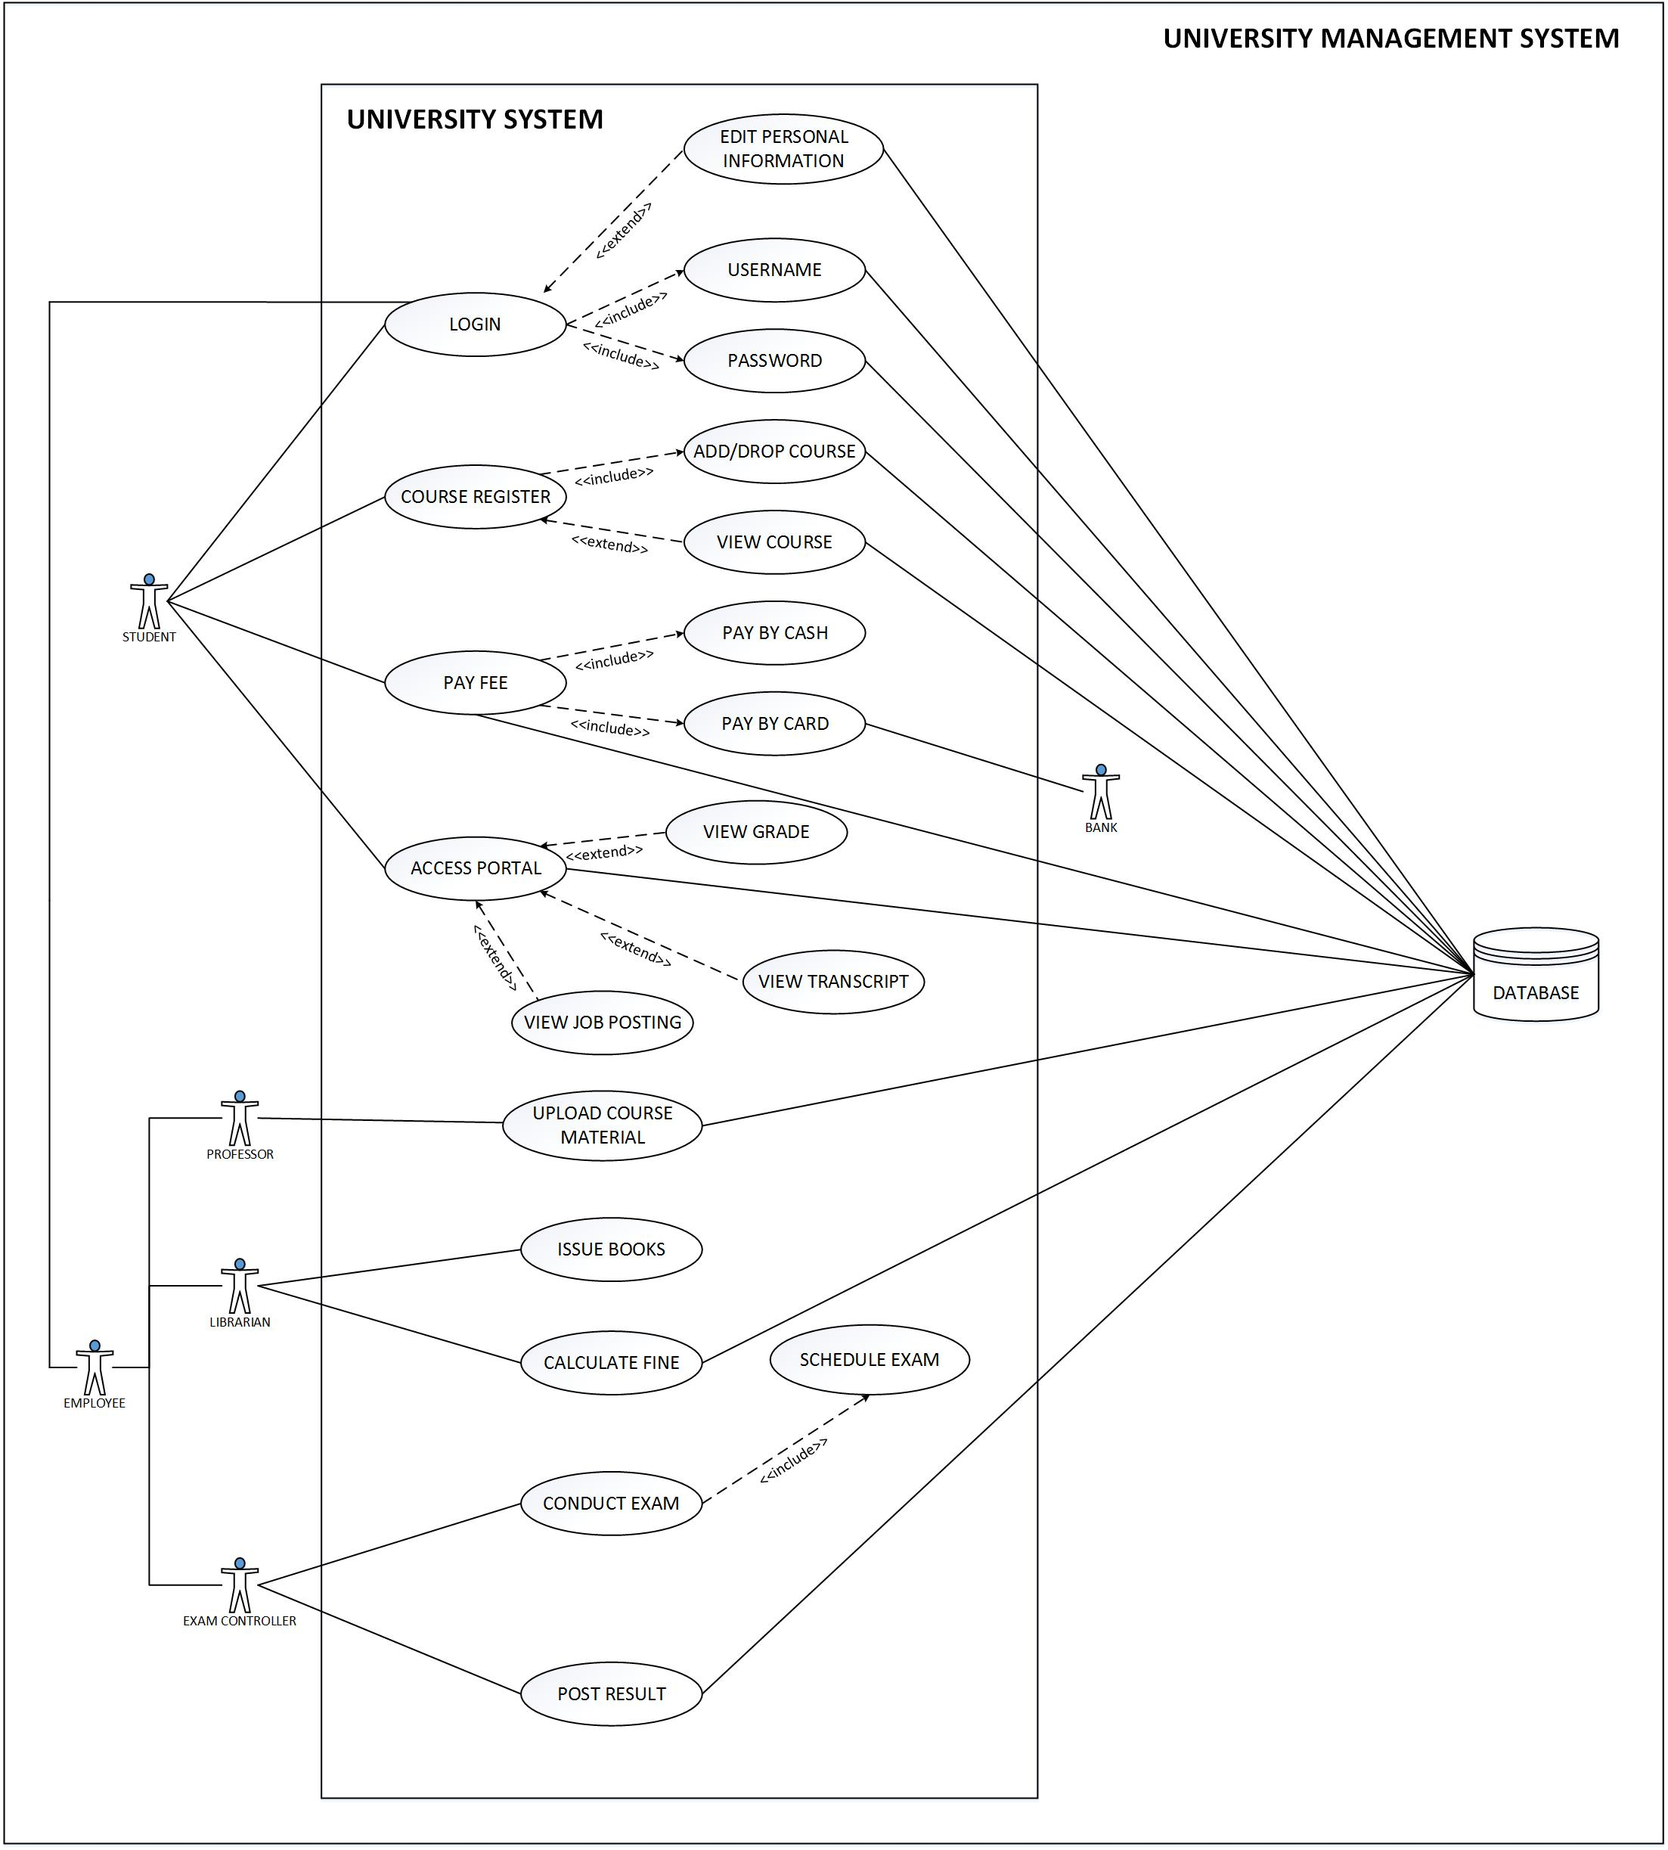**2.1 Use case Diagram**

**2.2 Use Case Description**

**UC-01: Login**

|  |  |
| --- | --- |
| **Use-Case ID:** | **UC-01** |
| **Use-Case Name:** | Login |
| **Summary:** | The user login in the portal |
| **Precondition:** | The user must be a registered member in the university. |
| **Post Condition:** | The student is able to login in the account |
| **Primary Actors:** | The student, Employees of the University |
| **Secondary Actors:** | Database |
| **Main Scenario:** | 1. The user opens the college portal website 2. The user enters the id and password 3. The user submits the information 4. The user is logged in to the portal if the credentials are correct. 5. The user is able to edit his/her personal information. |
| **Alternate Scenario:** | 4.a. The user must have a valid id and password  4.b. The error message is displaced when the credential(s) are incorrect |
| **Includes** | - |

**UC-02: Course Registration**

|  |  |
| --- | --- |
| **Use-Case ID:** | **UC-02** |
| **Use-Case Name:** | Course Registration |
| **Summary:** | The student login in the portal and registers the course |
| **Precondition:** | The course must be available |
| **Post Condition:** | The student successfully registers the course |
| **Primary Actors:** | The student |
| **Secondary Actors:** | Database |
| **Main Scenario:** | 1. The student login to the university portal. 2. The student views the available course for the semester. 3. The student enrolls for the course for a particular term. |
| **Alternate Scenario:** | 3.a. The student can enroll only up to a specified number of course  3.b. The student cannot enroll for the courses outside the department. |
| **Includes:** | UC – 01: Login |

**UC-03: Access Portal**

|  |  |
| --- | --- |
| **Use-Case ID:** | **UC-03** |
| **Use-Case Name:** | Access Portal |
| **Summary:** | The student can access the course material in the portal |
| **Precondition:** | The student is logged in. |
| **Post Condition:** | The student is able to view the course material. |
| **Primary Actors:** | Student |
| **Secondary Actors:** | Database, Professor |
| **Main Scenario:** | 1. The student logs in the system. 2. The student selects the course. 3. The student can view and download the course material. |
| **Alternate Scenario:** | 1.a The student enters wrong credentials.  1.b Go to step1. |
| **Includes** | - |

**UC-04: Issue Book**

|  |  |
| --- | --- |
| **Use-Case ID:** | **UC-04** |
| **Use-Case Name:** | Issue Book |
| **Summary:** | The librarian issues a book to the student. |
| **Precondition:** | The librarian is logged in the system. |
| **Post Condition:** | The database is updated for available books. |
| **Primary Actors:** | Librarian |
| **Secondary Actors:** | Database, Student |
| **Main Scenario:** | 1. The librarian logs into the system. 2. The librarian adds the code of the book to the database of available books for issue. 3. The librarian submits the information in the system. |
| **Alternate Scenario:** | 1. a. The librarian enters wrong credentials  1. b. Go to step 1. |
| **Includes** | - |

**UC-05: Calculate Fine**

|  |  |
| --- | --- |
| **Use-Case ID:** | **UC-05** |
| **Use-Case Name:** | Calculate Fine |
| **Summary:** | The librarian calculates fine. |
| **Precondition:** | The librarian is logged into the system. |
| **Post Condition:** | The overdue fine is added to the student’s account. |
| **Primary Actors:** | Librarian |
| **Secondary Actors:** | Database, Student |
| **Main Scenario:** | 1. The librarian logs into the system. 2. The librarian enters the code of the returned book. 3. The system shows the overdue message. 4. The librarian selects the calculate fine option. 5. The system calculates the fine. 6. The librarian selects the update student account option. |
| **Alternate Scenario:** | 1. a. The librarian enters wrong credentials  1. b. Go to step 1. |
| **Includes** | - |

**UC-06: Conduct Exam**

|  |  |
| --- | --- |
| **Use-Case ID:** | **UC-06** |
| **Use-Case Name:** | Conduct Exam |
| **Summary:** | The exam controller schedule rooms for exam. |
| **Precondition:** | The exam controller is logged in the portal. |
| **Post Condition:** | The room is reserved for conducting the exam. |
| **Primary Actors:** | Exam Controller |
| **Secondary Actors:** | Database |
| **Main Scenario:** | 1. The exam controller logs into the system. 2. The exam controller views the available rooms. 3. The exam controller selects the room. 4. The database is updated. |
| **Alternate Scenario:** | 1. a. The exam controller enters wrong credentials  1. b. Go to step 1. |
| **Includes** | - |

**UC-07: Post Results**

|  |  |
| --- | --- |
| **Use-Case ID:** | **UC-07** |
| **Use-Case Name:** | Post Results |
| **Summary:** | The exam controller must post the results |
| **Primary Actor:** | Exam controller |
| **Secondary Actor:** | Database, Student |
| **Precondition:** | 1. the user has logged into the system with username and password 2. He must have the results to update the exam controller has successfully posted the result |
| **Post condition:** | The exam controller has successfully posted the result |
| **Main Scenario:** | 1. The user logs into the system 2. It has a set of results to upload in the database 3. The results are uploaded and stored in the database |
| **Alternative Scenario:** | NA |
| **Exception flow:** | NA |
| **Includes:** | NA |

**UC-08: Add/Drop Courses**

|  |  |
| --- | --- |
| **Use-Case ID:** | **UC-08** |
| **Use-Case Name:** | **Add/Drop courses** |
| **Summary:** | The students or the advisor can register for the required course. The advisor can also help the student to enroll them in the desired course. The student further wants to add/drop the courses |
| **Primary Actor:** | Student |
| **Secondary Actor:** | Database |
| **Precondition:** | 1. The student or the advisor must login with the required username and the password  2. the student wants to add/drop the courses |
| **Post condition:** | The student adds/drop the course |
| **Main Scenario:** | 1. The student/advisor logs in the system  2. The student want to add/drop the course  3. Either the advisor or student adds/ drops the courses |
| **Alternative Scenario:** | NA |
| **Exception flow:** | NA |
| **Includes:** | UC-09: Course Registration |

**UC-09: View Course**

|  |  |
| --- | --- |
| **User ID:** | **UC-09** |
| **User-Case Name:** | View Course |
| **Summary:** | The students or the advisor can register for the required course. The advisor can also help the student to enroll them in the desired course. The student further wants to view the courses. |
| **Primary Actor:** | Student |
| **Secondary Actor:** | Database |
| **Precondition:** | 1. The student or the advisor must login with the required username and the password 2. The student wants to view the courses |
| **Postcondition:** | The student checks and view the courses |
| **Main Scenario:** | 1. The student/advisor logs in the system 2. The student wants to view the course 3. Either the advisor or student can view the courses for the student |
| **Alternative Scenario:** | NA |
| **Exception Flow:** | NA |
| **Include:** | UC-09: Course Registration |

**UC-10: Pay Fees**

|  |  |
| --- | --- |
| **User ID:** | **UC-10** |
| **User-Case Name:** | Pay Fees |
| **Actor:** | Student, database |
| **Summary:** | The students must pay the fees by either using the card or by cash. |
| **Primary Actor:** | Student |
| **Secondary Actors:** | Bank, Database |
| **Precondition:** | 1. The student must login with the required username and the password 2. The student must register the courses for recent or upcoming terms. |
| **Post condition:** | The student logs in and then they can pay the fee using their appropriate ways. |
| **Main Scenario:** | 1. The student logs in the system 2. The student can pay the fees by cash or by debit/credit card |
| **Alternative Scenario:** | The student can go to the bank and pay fee from there. |
| **Exception Flow:** | NA |
| **Includes:** | NA |

**3. Functional Requirements:**

1. **Login**

The user must be able to login into the system using ID and password.

1. **Register courses**

The student should be able to register in various available courses.

1. **Pay Fees**

The student can pay fees using various available options.

1. **Access Portal**

The student can access portal and view grades and other academic documents.

1. **Edit Personal Information**

The user has the ability to edit his/her personal information.

1. **View Courses**

The student can view and download the course material.

1. **Issue Book**

The librarian can issue the book to the student.

1. **Calculate fine**

The librarian can calculate fine for overdue books.

1. **Conduct exam**

The exam controller can schedule room for conducting exam.

1. **Post result**

 The exam controller can post the exam results of the students.

**4. Contribution Table**

|  |  |  |  |  |
| --- | --- | --- | --- | --- |
|  | **Domain Description** | **Use Case Diagram** | **Use Case Description** | **List of Requirements** |
| Hem Raj Regmi | √ | √ | Pay Fees, Report Preparation |  |
| Bitta Rani Rana | √ | √ | Login, Course Registration |  |
| Aeisha Vyas |  | √ | Post Result, View/Add Course | √ |
| Manjot Kaur Grewal |  | √ | Access Portal, Issue Books | √ |
| Harmanpreet Kaur Rajput |  | √ | Calculate Fine, Conduct Exam | √ |

**GitHub:** <https://github.com/sangamsyabil/COEN6312---College-Management-System>